The business requirement for this project is: “a normalized relational database of corporate financial information for all 7,500 U.S. listed public companies, including specific data elements, going back at least 3 years, a semi-automated system to update it going forward, and a simple website to query and report on the data.”
An open data source must be used: screen-scraping, non-commercial, subscription based, or unauthorized use of data will not be permitted. Currently the only known open data source is the SEC EDGAR system, where companies file mandatory quarterly and annual reports containing this information in a human-readable electronic format.
The solution consists of several components:
- SEC EDGAR Data Feed. This has been implemented. The local server contains a full collection of SEC EDGAR files, indexed in a MySQL database. The data includes 10-Q (quarterly reports) and 10-K (annual reports) for all 7,500 companies and is always kept current by a nightly update process.
- Document Splitter. This has been 90% implemented. Scripts are in place which are capable of splitting up each document into sections, dumping into valid XML, and cleaning up heavily formatted HTML tables into clean TABLE/TR/TD tags.
- Section Finder. This has been 50% implemented. By using Bayesian filters written in Python, it is possible to train the system to identify which section of a document contains the relevant data. The scripts are in place for this but they are poorly integrated and very buggy.
- Automated Data Entry. Once the correct document section has been identified by the Section Finder, the Automated Data Entry component should be able to correctly extract the data elements 80% of the time using a simple “table walk” algorithm. This component has not been designed or coded yet.
- Manual Data Entry. For the remaining 20% of data which is not extracted by the Automated Data Entry component, a web-based application allows a team of data-entry operators to locate the data with the help of the Section Finder, and manually type it into a structured input form. This component does not exist yet.
Work is currently required to get all the components finished, integrated, tested, and working together to meet the project objective of a complete, searchable database.
For the components that have already been developed, there is a demo below:
http://edgar.zigabyte.net/result.php?search=1
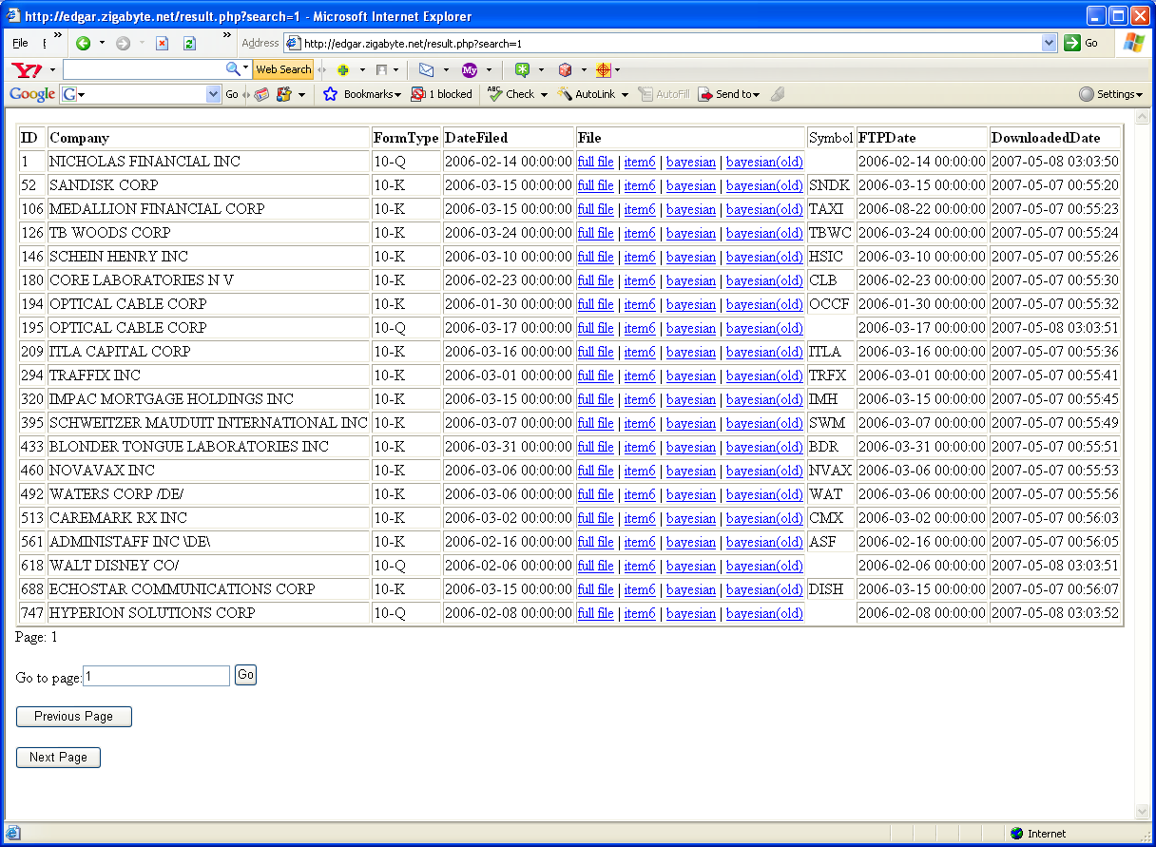

The specific fields which are required for the database and for the demo website are:
Field Name | Type | Description | Source
ID | int(4) | An auto-increment ID field, Primary Key. | System generated
CompanyID | int(2) | A cross-reference field to another table (existing) which contains the company name, symbol, and Central Index Key | Existing db table
FileID | int(4) | Cross-reference to the file that contains this data | Existing db table
Revenue | decimal(14,2) | The company total revenues (a.k.a. “sales”), in USD. | Income Statement
Earnings | decimal(14,2) | The company’s total earnings (a.k.a. “net income”), in USD. | Income Statement
Dividends | decimal(14,2) | Dividends paid out, in USD. | Income Statement
Float | decimal(12) | Number of shares outstanding. | Varies
Debt | decimal(14,2) | Total liabilities | Balance Sheet
Equity | decimal(14,2) | Shareholder’s equity | Balance Sheet
Cash | decimal(14,2) | Cash – current assets | Balance Sheet
StartDate | date | Starting period of this data row | Column heading
EndDate | date | Ending period of this data row | Column heading

The specific fields are explained in the next page.

